|  |
| --- |
| P1 Scanner 100% Complete |
| Julia Scanner |
| Sharon Perry CPL 4308 Section 03 |

|  |
| --- |
| Ronak Patel  3-6-2022 |

B.

The main loop of my program occurs in LexLoop where it keeps building lexemes and figuring out what they are. Build next lexeme calls find next lexeme and that function removes comments and whitespace until new lines are found. Build next lexeme builds the string one char at a time. LexLoop then uses that string to find out what type of lexeme it is, which can go into different categories. It can be a keyword, Identifier, or a literal. These are functionalized to return bool types for condition statements. Token types were created to account for the basic things I would run into via my test cases and the language grammar.

C.

I created TokenTypes.CS which was a enum type that had all the types I needed to classify my tokens. Scanner.CS held all my functions used up above such as lexloop, buildnextlexeme, findnextlexeme, and various other functions. TokenTypes was used for my dictionary to not have to go one by one checking each value until I found my lexeme matching my token.

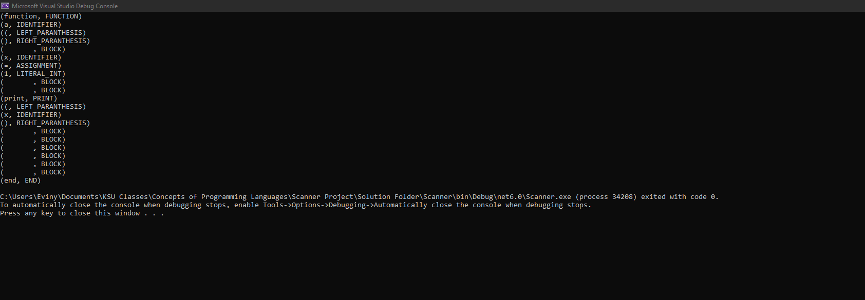D.

